

Topic test 1
Name: __________________________________

Chapter 6: Time series analysis

• Time allowed: 45 minutes
• CAS calculators may be used
• Part A: 8 multiple-choice questions (8 marks)
• Part B: 6 short-answer questions (34 marks)
• Part C: 2 analysis questions (20 marks)
Part A
Multiple-choice questions
8 multiple-choice questions
1 mark each: 8 marks
Circle the correct answer.
1 The time series graph shown below displays:
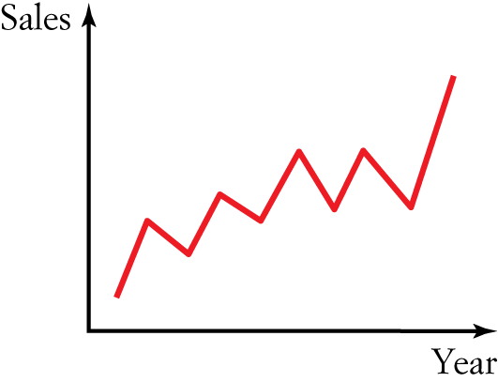
A Random fluctuations only
B Seasonal variation
C Cyclic variation
D A secular positive trend
E A secular negative trend

[1 mark]

2 The time series graph shown below displays:
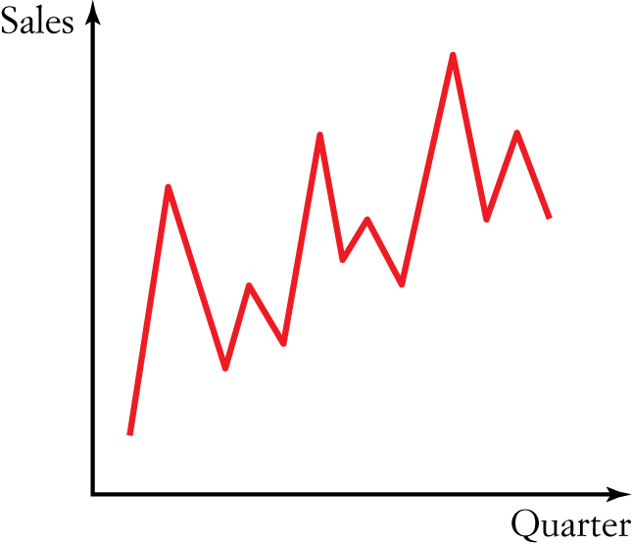
A Random fluctuations only
B Seasonal variation
C Cyclic variation
D A secular positive trend
E A secular negative trend

[1 mark]
3 The seasonal indices (SI) for sales of sunglasses by a factory outlet are shown in the table below.
Quarter | 1 | 2 | 3 | 4
SI | 1.23 | 0.97 | 0.66 | 1.14
The actual number of sunglasses sold in the fourth quarter was 163. The seasonally adjusted sales figure is closest to:
A 143
B 114
C 164
D 186
E 123

[1 mark]

4 The seasonal indices (SI) of the sales from a retail outlet are shown in the table below.
Quarter | SI
1 | 0.9
2 | 1.4
3 | 1.3
4 | 0.4
For the first quarter of the year, the deseasonalised sales were $50 000. The actual sales figure for the first quarter was:
A $55 556
B $45 000
C $38 462
D $50 000
E $125 000

[1 mark]
5 For the points (1, 1), (2, 2.5), (4, 5.5), the linear regression line can be expressed as:
A y  1.4t  6.25
B y  1.5t  6.25
C y  1.5t  0.5
D y  1.5t  0.5
E y  3t  8.5

[1 mark]
6 For the following time series situation, which is most likely to apply?
Sales of gumboots in London
A Positive secular trend
B Negative secular trend
C Seasonal pattern
D Cyclic pattern
E Random pattern

[1 mark]
7 A manufacturer of DVD players has determined the quarterly proportions shown below describing the shop’s quarterly sales projected figures for 3 years.
Year | Q1 | Q2 | Q3 | Q4
2014 | 0.70 | 0.86 | 1.08 | 1.36
2015 | 0.64 | 0.85 | 1.23 | 1.28
2016 | 0.53 | 0.91 | 1.45 | 1.11
The seasonal index for the first quarter is:
A 1.25
B 0.71
C 0.87
D 1.25
E 0.62

[1 mark]
8 A teacher wanted to analyse the number of absences in his classes. He listed the daily average absentee rates for Year 9 students for each term over a 2-year period and calculated these seasonal indices:
Year | Q1 | Q2 | Q3 | Q4
Seasonalised index | 0.60 | 0.95 | 1.08 | 1.37
If the equation describing the deseasonalised data is:
Absences × 1.2  Term  27
the predicted actual number of absences in the first term of the third year is:
A 23
B 38
C 28
D 42
E 25

[1 mark]

Part B
Short-answer questions
6 short-answer questions
34 marks
Show your working where appropriate.
1 a Use the three-median method to smooth the following data set and plot the resulting graph.
t | 1 | 2 | 3 | 4 | 5 | 6 | 7 | 8 | 9 | 10
y | 3 | 5 | 6 | 10 | 9 | 16 | 12 | 16 | 17 | 20

b What type of trend is this?

[5 marks]
2 The following table shows the share price of a company during a volatile period in the stock market.
Day t | 1 | 2 | 3 | 4 | 5 | 6 | 7 | 8 | 9 | 10
Price y ($) | 3.23 | 5.55 | 6.36 | 10.1 | 9.1 | 16.2 | 12.1 | 16 | 17.25 | 10.1
a Use the three moving averages method to smooth the following data set. Plot the resulting graph.

b What type of trend is this?

[5 marks]
3 Draw a time series plot and describe its features for the following data set.
t | 1 | 2 | 3 | 4 | 5 | 6 | 7 | 8
y | 3 | 5 | 6 | 10 | 1 | 4 | 5 | 16

[4 marks]
4 A holiday maker records the number of sightings, y, of rosellas in the Colac Otways that he observes each day, t, and constructs the following table.
t | 1 | 2 | 3 | 4 | 5 | 6 | 7 | 8
y | 3 | 5 | 6 | 1 | 1 | 4 | 5 | 1
a Draw a time series plot and describe its features.

b Find the least squares regression line and add it to your time series plot.

[6 marks]
5 Staff in a small country hospital tabulated the number of births recorded over a period of 3 years as shown in the table below.
Year | Q1 | Q2 | Q3 | Q4
2011 | 0 | 4 | 1 | 5
2012 | 1 | 5 | 1 | 4
2013 | 1 | 2 | 5 | 1
a Create a time series plot using the data given.

b Using technology, find the least squares regression line and add it to your time series plot.
c State the equation of the least squares regression line.

d Use the equation to predict the number of births in the small country hospital in the first quarter of 2014.

[8 marks]

6 An ice-cream cone seller is trying to predict his sales figures for 2014. He is trying out a new liquorice flavour and has tabulated his sales figures of the liquorice flavour for the years 2008 to 2013:
Year t | 2008 | 2009 | 2010 | 2011 | 2012 | 2013
Sales y  ($1000s) | 16 | 12 | 10 | 15 | 17 | 16
Using a four-point moving median with centring, smooth the data and use it to predict his sales for 2014.

[6 marks]

Part C
Analysis questions
2 analysis questions
20 marks
Show your working where appropriate.
1 A teacher recorded the number of students absent per week for 10 days and the results are displayed in the graph below.
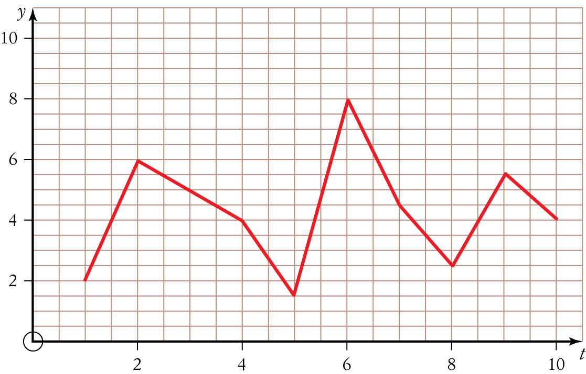
a Smooth the time series data using three-point median smoothing.

b Use the smoothed data to predict absences for day 11.

c Smooth the time series data using a four-point moving average.

d Describe the trend shown.

[10 marks]
2 The quarterly sales figures (number of cars sold) recorded by a car sales yard for each of the years from 2010 to 2012 are shown in the table below.
Year | Sales figures  quarter 1 | Sales figures  quarter 2 | Sales figures  quarter 3 | Sales figures  quarter 4
2010 | 5 | 7 | 9 | 3
2011 | 4 | 8 | 9 | 4
2012 | 5 | 9 | 10 | 5
a Calculate the seasonal index for each quarter.

b Deseasonalise the data.

c Plot the original and the deseasonalised time series data.

[10 marks]
[ Total marks: 62]

Answers
Part A – Multiple-choice questions [1 mark each]
1 The time series data over the year shown is moving in an overall positive direction.
∴ D
2 The time series data shown is for a period of 3 months. If we were to divide the graph into three sections, one for each month, then we can see that there is a distinct pattern that repeats each month.
∴ B
3 Deseasonalised value  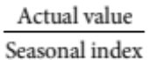
 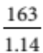
 142.982 …
≈ 143
∴ A
4 Actual value  Seasonal index  Deseasonalised value
 0.9  50 000
 45 000
∴ B
5 CAS required to plot the points and create the least squares regression line, as shown below.
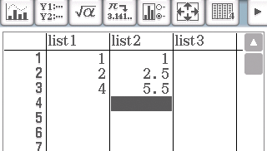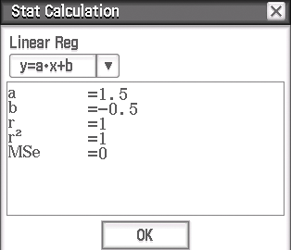
∴ D
6 A seasonal pattern is most likely to apply, as people are more likely to buy gumboots during rainy seasons.
∴ C
7 Seasonal index for first quarter
 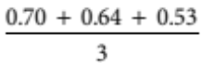
 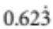
≈ 0.62
∴ E
8 Absences = 1.2  Term  27
= 1.2  1  27
= 28.2
≈ 28
∴ C
Part B – Short-answer questions
1 a | t | 1 | 2 | 3 | 4 | 5 | 6 | 7 | 8 | 9 | 10
 | y | 3 | 5 | 6 | 10 | 9 | 16 | 12 | 16 | 17 | 20
 |  |  | Med  (3,5,6)  = 5 | Med  (5,6,10)  = 6 | Med  (6,10,9)  = 9 | Med  (10,9,16)  = 10 | Med  (9,16,12)  = 12 | Med  (16,12,16)  = 16 | Med  (12,16,17)  = 16 | Med  (16,17,20)  = 17
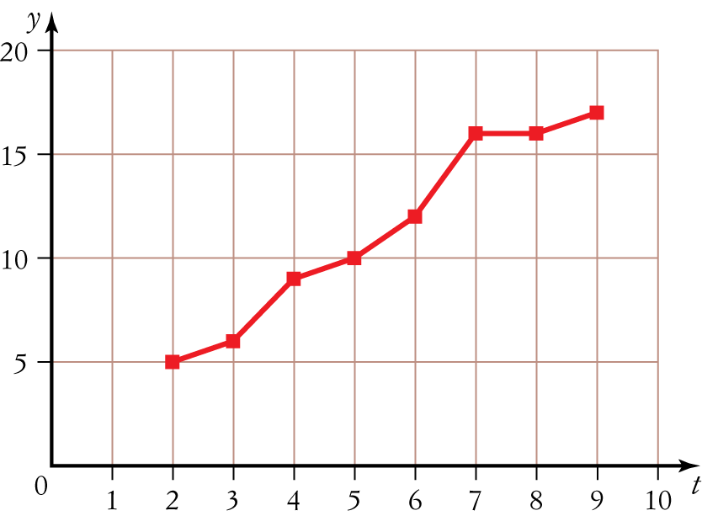
[4 marks]
b Positive secular trend [1 mark]
2 | t | 1 | 2 | 3 | 4 | 5 | 6 | 7 | 8 | 9 | 10
 | y ($) | 3.2 | 5.6 | 6.4 | 10.1 | 9.1 | 16.2 | 12.1 | 16 | 17.3 | 10.1
 |  |  | (3.2 + 5.6 + 6.4)/3 | (5.6 + 6.4 + 10.1)/3 | (6.4 + 10.1 + 9.1)/3 | (10.1 + 9.1 + 16.2)/3 | (9.1 + 16.2 + 12.1)/3 | (16.2 + 12.1 + 16.0)/3 | (12.1 + 16.0 + 17.3)/3 | (16.0 + 17.3 + 10.1)/3
 |  |  | = 5.1 | = 7.4 | = 8.5 | = 11.8 | = 12.5 | = 14.8 | = 15.1 | = 14.5
a 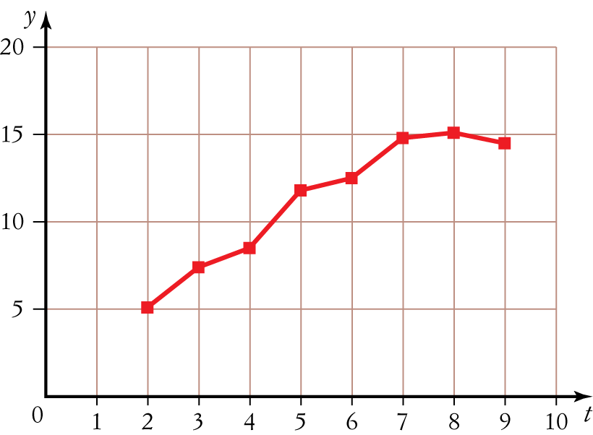
[4 marks]
b Positive secular trend [1 mark]
3 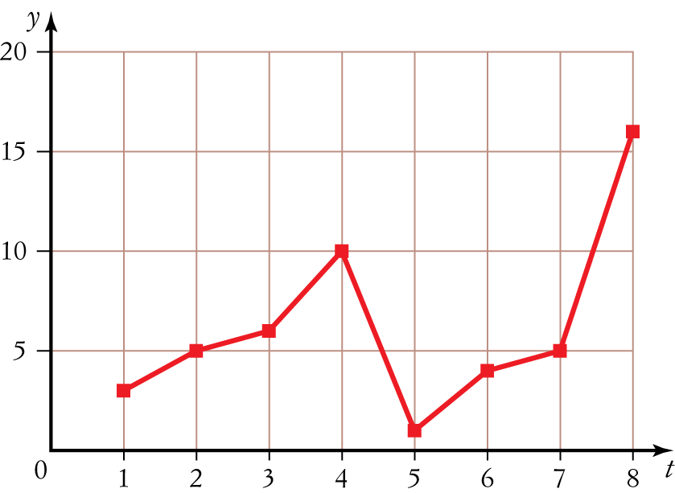
[3 marks]
Graph shows a cyclic trend peaking every fourth point. [1 mark]

4 | t | 1 | 2 | 3 | 4 | 5 | 6 | 7 | 8
 | y | 3 | 5 | 6 | 1 | 1 | 4 | 5 | 1

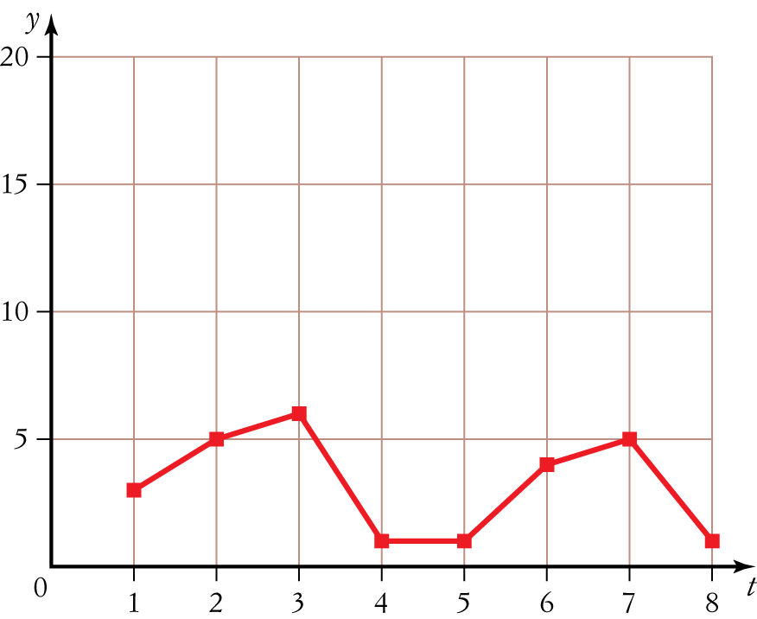
a
Plot has a lot of variation but, overall, rosella numbers are decreasing.
[3 marks]

b Equation of least squares regression line is y  0.24t  4.32. [1 mark]
Addition to the time series plot of the least squares regression line is shown below.
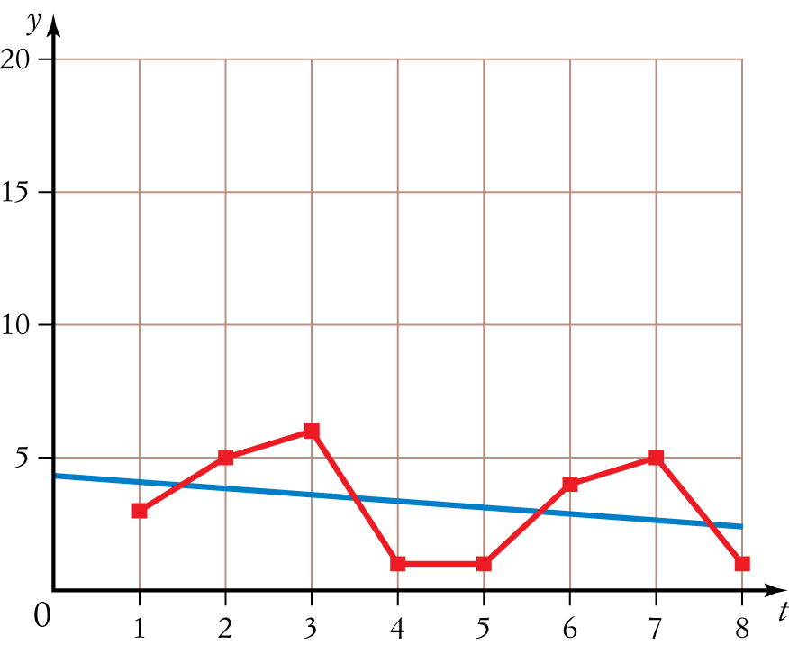
[2 marks]
5 a 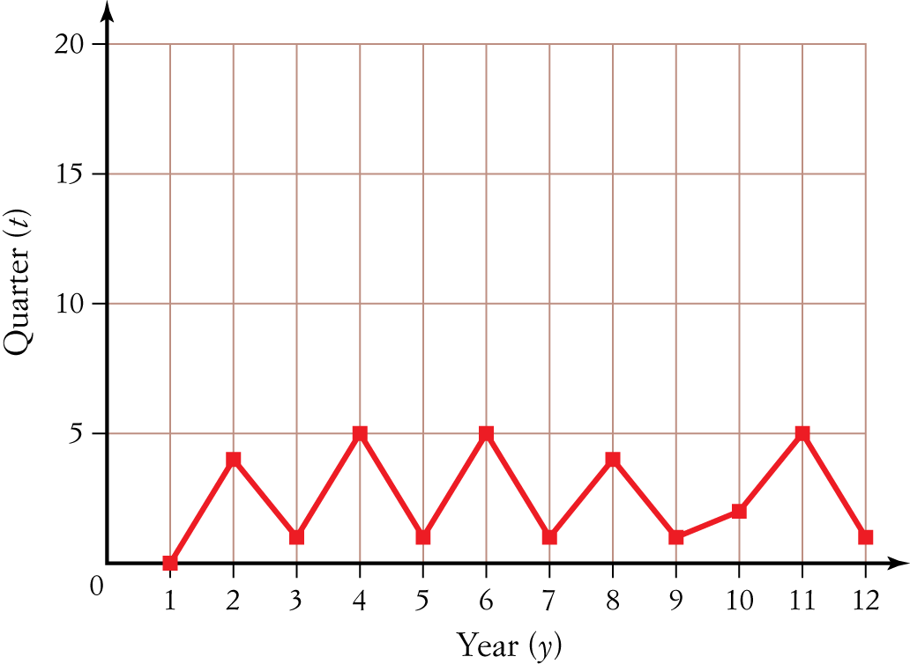
[3 marks]
b 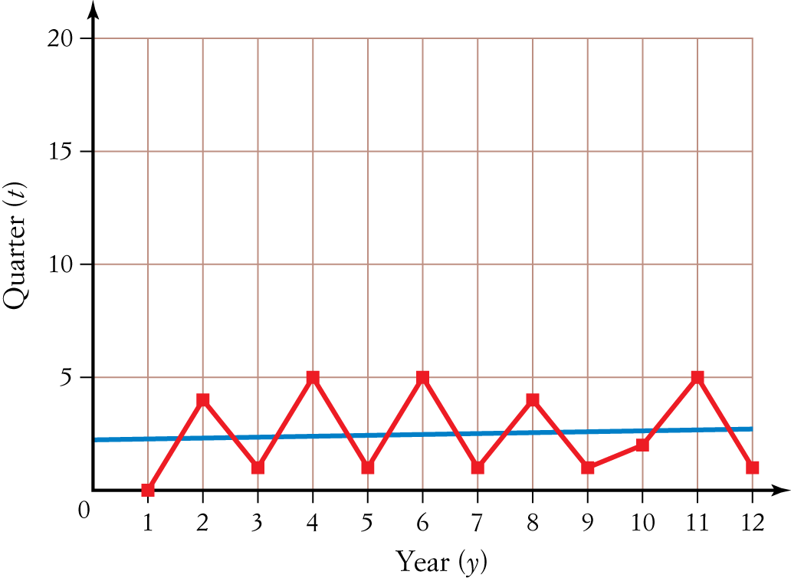
[2 marks]
c y  0.04t  2.23 [1 mark]
d At t  13, y  0.04  13  2.23  2.75
Round up to 3 births.
Predicted number of births for the first quarter of 2014 is three. [2 marks]
6
Year t/Sales y ($1000s) |  | Four-point moving median | Four-point moving median with centring
1 | 16
2 | 12
 |  | Med (16,12,10,15) = 13.5
3 | 10 |  | 13.5
 |  | Med (12,10,15,17) = 13.5
4 | 15 |  | 14.5
 |  | Med (10,15,17,16) = 15.5
5 | 17
6 | 16
[3 marks]
Trend line: y  t  12.5 [1 mark]
Sales for 2014: t  7
y  7  12.5
 19.5
 $19 500 in sales predicted for 2014 [2 marks]
Part C – Analysis questions
1 a
Day t | Students absent y | Three-point median average
1 | 2
2 | 6 | Med (2,6,5) = 5
3 | 5 | Med (6,5,5) = 5
4 | 5 | Med (5,5,2) = 5
5 | 2 | Med (5,2,8) = 5
6 | 8 | Med (2,8,5) = 5
7 | 5 | Med (8,5,3) = 5
8 | 3 | Med (5,3,5) = 5
9 | 5 | Med (3,5,4) = 4
10 | 4

[3 marks]
b Trend line: y  5.33  0.08t
When t  11, y  4.5. Round up to 5 absences.
Therefore, the predicted number of absences for day 11 is five.
[2 marks]
c Smoothing the time series data using a four-point moving average gives the following:
Day t | Students absent y | Four-point moving average | Four-point moving average with centring
1 | 2
2 | 6
 |  | (2  6  5  5)/4  4.5
3 | 5 |  | 4.5
 |  | (6  5  5  2)/4  4.5
4 | 5 |  | 4.75
 |  | (5  5  2  8)/4  5
5 | 2 |  | 5
 |  | (5 2  8  5)/4  5
6 | 8 |  | 4.75
 |  | (2  8  5  3)/4  4.5
7 | 5 |  | 4.875
 |  | (8  5  3  5)/4  5.25
8 | 3 |  | 4.75
 |  | (5  3  5  4)/4  4.25
9 | 5
10 | 4
[4 marks]
d Trend is best described as cyclic. [1 mark]
2
Year | Sales figures quarter 1 | Sales figures quarter 2 | Sales figures quarter 3 | Sales figures  quarter 4 | Yearly average
2010 | 5/6 | 7/6 | 9/6 | 3/6 | 24/4  6
2011 | 4/6.25 | 8/6.25 | 9/6.25 | 4/6.25 | 25/4  6.25
2012 | 5/7.25 | 9/7.25 | 10/7.25 | 5/7.25 | 29/4  7.25
SI | 0.72 | 1.23 | 1.44 | 0.61

a
[4 marks]
SI | 0.72 | 1.23 | 1.44 | 0.61
Year | Sales figures quarter 1 | Sales figures quarter 2 | Sales figures quarter 3 | Sales figures quarter 4
2010 | 5/0.72 = 6.94 | 7/1.23 = 5.69 | 9/1.44 = 6.25 | 3/0.61 = 4.92
2011 | 4/0.72 = 5.56 | 8/1.23 = 6.50 | 9/1.44 = 6.25 | 4/0.61 = 6.56
2012 | 5/0.72 = 6.94 | 9/1.23 = 7.32 | 10/1.44 = 6.94 | 5/0.61 = 8.20
b

Deseasonalised data
Year | Sales figures  quarter 1 | Sales figures  quarter 2 | Sales figures  quarter 3 | Sales figures  quarter 4
2010 | 6.94 | 5.69 | 6.25 | 4.92
2011 | 5.56 | 6.50 | 6.25 | 6.56
2012 | 6.94 | 7.32 | 6.94 | 8.20

[4 marks]
c Original time series data
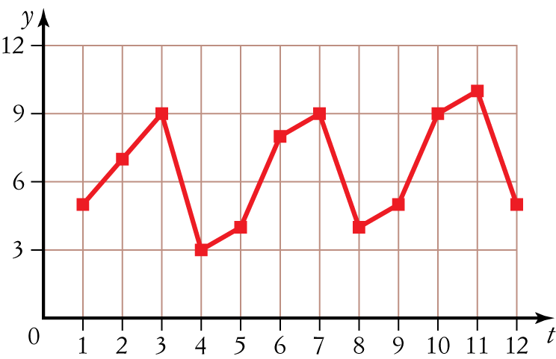
Deseasonalised time series data
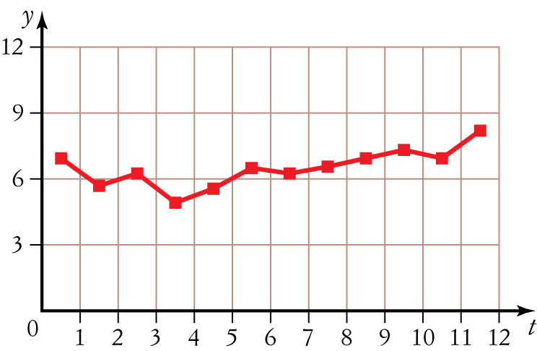
[2 marks]

